Renju lesson on November 15, 2001
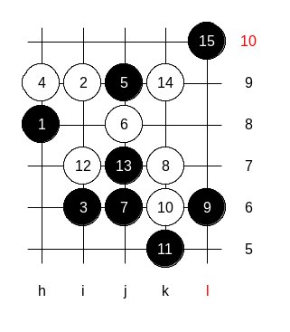
Hello everyone! Welcome to Online Renju Class. Today is the last day we study i8 opening. Move 5-j9 is the topic of today’s lesson. Lets try some 6th moves here. Move 6-j8 quite interesting. How should black act here? So many of you suggested 7-j6, shall we try it? How to continue after the 10th move? We do not know if white can win or not. I am showing you the key point of the structure. Whoever takes that point has better chances in this game. It is the k6 point. White got that point and offered a strong resistance.

Black will take that point first on 7th move. The idea is to cut off the connections of h9 stone to lower side. Black will now give up externally strong point j6, I know. But if you look at the lower side space and black stones advantage there, you realize that black can afford giving up some key points of its own as long as it keeps white stones separated. The point is, even after giving up the j6 point, black has still enough forces to win. The only obstacle for black could be white counter activity, but now black has taken care of it.
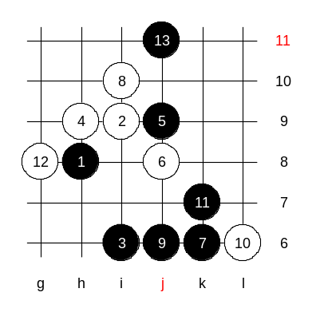
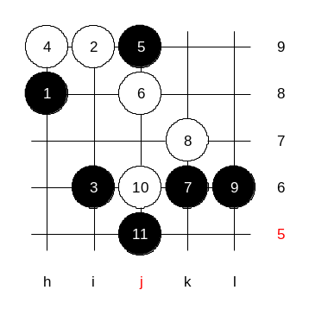
Now, one more aspect of k6 move. Before making such move, black must be sure white cannot counter attack. Look closely: Black has only one like, and white has a controller at L6, right? That would make us worry, what is white makes a development move and black does not have VCT. But that’s all right. Black does not have to have its own VCT as long as black can create its own control structure. See the diagram, black uses control style. So, sometimes we do not need to worry too much about the absence of VCF, but it is enough if we can create the necessary controllers. Now black wins.

Here, in case of passive style, white is unable to defend either. Black j5 gives easy win.

So, we have understood the idea of the key move 7-k6.

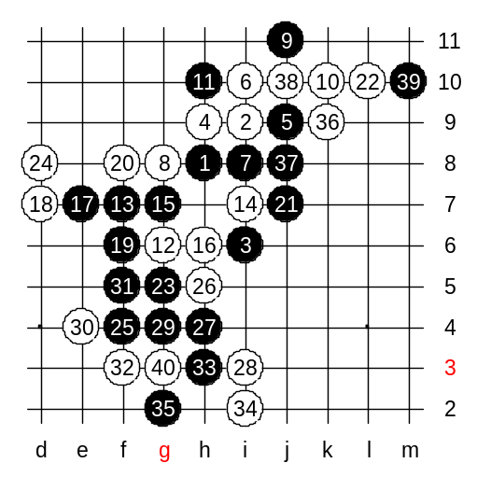
Now we will go to the main 6th move. It is 6-10. The following moves are practically forced, so we go through them without delay. Now there are 15 stones on the board. This is the main position of the 4th move. We will study 16-h6 first. This is Nakamura’s move. He used it successfully before. Does anyone of you have the Click of Stones book? That book claims that black has no win here. (page 103, 2nd diagram).
Now, after 22 moves, Click of Stones book offers a variant and claims the absence of win. The book variant ends here, after 26th move. Indeed, black seem to have no win after 26th move. Let’s find out. See the defense of white.!

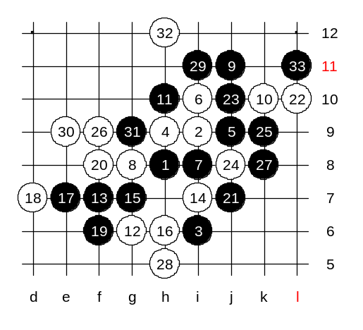
However, black can still win few two moves. Can you find?

I show you one more idea. My analysis proves such easy win: White must play f9, to avoid two side win. K8! A great timing move. Now white has no time to use four below. So white must block the three from lower side. Easy win follows in upper side.
So, which of these two wins is easier?

The last diagram today. We will take a quick look at another 16th move.
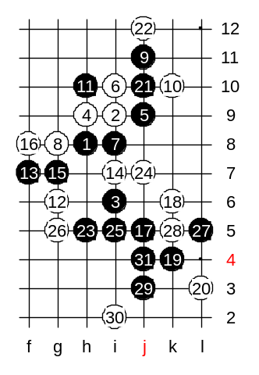
Move 16-f8 is the traditional move here. Well, I do not have the records of sure win variants here, but it does look like sure win. (16-e7 is weak because black diagonal g7_h6 is very important). Now, there are two main development ideas – 17-h4 and 17-j5. They both have the idea of its own. In order to understand the pattern better, remember that when black plays a three to j10, white must block it form the top. So, it would give us important link to j7 point. And remember the rule of space move, when we have the necessary link, then we can make a space move. (17-L10 is not so good because it gives white some chance to balance below). We can try 17-j5.

